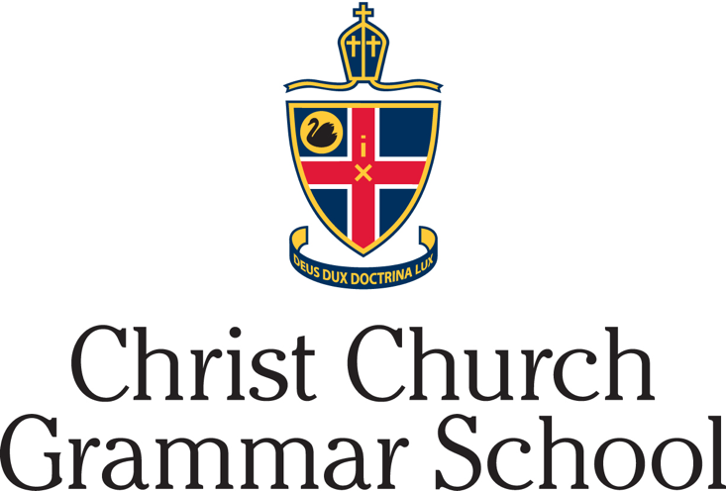

Year 12 Chemistry
Organic Chemistry Test
2020

Time allowed: 45 minutes

Name:

Teacher: MXC KLW CEM NMO

Mark = ………/46

SECTION 1 MULTIPLE CHOICE 10 marks

1. Which of the following organic compounds would be the most soluble in water?

A. Butane
B. Butan-1-ol
C. Butanoic acid
D. Butyl butanoate

2. Which of the following lists the compounds in order of increasing boiling point?

A. propanamide < propan-1-ol < propanamine < propane
B. propane < propanamine < propan-1-ol < propanamide
C. propane < propan-1-ol < propanamine < propanamide
D. propane < propanamide < propan-1-ol < propanamine

3. The properties of three organic compounds X, Y and Z are described below.

- X and Y react together in the presence of concentrated sulfuric acid to produce a sweet smelling liquid.
- X and Z are isomers of each other.
- When added to acidified potassium permanganate, X produces a colour change but Y and Z do not.

Select the option in the table that correctly identifies X, Y and Z.

 | X | Y | Z
A | Butan-1-ol | Butanoic acid | Butan-2-ol
B | Butanoic acid | Ethanol | Methyl propan-2-ol
C | Propan-1-ol | Ethanol | Propan-2-ol
D | Butan-1-ol | Ethanoic acid | Methyl propan-2-ol

4. Which of the following pairs have the same empirical formulae?

A. ethyl ethanoate and ethanal
B. propanone and ethanol
C. ethanoic acid and ethanol
D. methyl methanoate and propanone

5. Which functional groups are present in the following molecule?

A. two primary amines, ester, ketone, alkene
B. amide, ester, alkene, primary amine
C. two primary amines, two ketones, alkene
D. amide, ketone, alkene, primary amine

6. Which two compounds can be distinguished by the addition of acidified potassium dichromate?

A. ethanoic acid and propan-1-ol
B. butan-2-ol and butan-1-ol
C. propanone and methyl propan-2-ol
D. ethanol and ethanal

7. The following ester is hydrolysed in the presence of sodium hydroxide.

Which of the following correctly lists the two products of this hydrolysis reaction?

A. methanol and sodium propanoate
B. propan-2-ol and methanoic acid
C. propan-2-ol and sodium methanoate
D. propan-1-ol and methanoic acid

8. Which of the following compound(s) could react to form a polyester?

A. HOOC(CH₂)₅OH
B. HO(CH₂)₅CH₃ and CH₃(CH₂)₃CH₂COOH
C. H₂N(CH₂)₅NH₂ and HOOC(CH₂)₃COOH
D. CH₃(CH₂)₅COOH and HO(CH₂)₈OH

9. A polymer is formed from the following two monomers, with molecular weights of 104 and 76 gmol⁻¹ respectively. Determine the molecular weight of the polymer if it contains 50 recurring units.

A. 8100 gmol⁻¹
B. 9000 gmol⁻¹
C. 8118 gmol⁻¹
D. 8982 gmol⁻¹

10. Examine this section of the structure of an addition polymer:

CH₃ CH₃ C CH₃ CH₃

C CH₂ C CH₂ C CH₂ CH₂ C CH₂ C

C C CH₃ C C

Which one of the following compounds could polymerise to form this chain?

- cis 1-chloropropene
B. 2-chloropropene
C. 3-chloropropene
D. 2-chlorobut-1-ene

SECTION 2 SHORT ANSWERS 36 marks

Question 11 8 marks

Draw the full structural formulae and name the following compounds, showing ALL bonds and atoms:

Description | Structure
The product of the reaction between cis but-2-ene and bromine water. | Name:  Structure:
A compound that has an empirical formula of C₂H₄O and produces a colourless, odourless gas when added to Mg (s). | Name:  Structure:
The main organic product formed from the reaction between methanol and excess acidified potassium permanganate. | Name:  Structure:
An isomer of pentan-2-ol that has a lower boiling point. | Name:  Structure:

Question 12 4 marks

Write a chemical equation/s to show how the following products can be made. Include relevant catalysts.

(a) sodium propoxide (CH₃CH₂CH₂ONa) 2 marks

(b) methyl ethanoate 2 marks

Question 13 7 marks

Ethanol, pentan-1-ol and ethyl pentanoate all have differing boiling points and solubilities in water.

- Molecules of ethanol and pentan-1-ol can both form hydrogen bonds, dipole-dipole interactions and dispersion forces with each other. However, pentan-1-ol (280°C) has a higher boiling point than ethanol (78°C). Explain why. 3 marks

______________________________________________________________________________________________________________________________________________________________________________________________________________________________________________________________________________________________________________________________________________________________________________________________________________________________________________________

- Ethanol and pentan-1-ol are both soluble in water, however ethyl pentanoate is not. Explain why ethyl pentanoate is insoluble in water.
4 marks

_________________________________________________________________________________________________________________________________________________________________________________________________________________________________________________________________________________________________________________________________________________________________________________________________________________________________________________________________________________________________________________________________________________________________________________________________________________________________________________________________________________
__________________________________________________________________________________________________________________________________________________

Question 14 8 marks

8.00 g of ethanol (M = 46.068 gmol⁻¹) and 8.00 g of propanoic acid (M = 74.058 gmol⁻¹) were mixed together. 1.00 mL of concentrated H₂SO₄ was added and the mixture warmed for 15 minutes. The reaction was stopped by the addition of water.

- Draw the major organic product formed. 1 mark

- 8.25 g of the product was collected using a separating funnel. Determine the yield of the reaction. 5 marks

____________________________________________________________________________________________________________________________________________________________________________________________________________________________________________________________________________________________________________________________________________________________________________________________________________________________________________________________________________________________________________________________________________________________________________________________________________________________________________________________________________________________________________________________________________________________________________________________________________________________________________________________________________________________________________
- Give one reason why the yield is not closer to 100%. Explain. 2 marks
____________________________________________________________________________________________________________________________________________________________________________________________________________________________________________________________________________________________________
Question 15 9 marks

An unknown hydrocarbon, Compound X, contains 32.00 % by mass carbon, 6.71 % by mass hydrogen, as well as oxygen and nitrogen.

A 2.07 g sample of the hydrocarbon was treated to convert all the nitrogen to ammonia, producing a 250 mL solution. 20.00 mL aliquots of this ammonia solution were then titrated against 0.120 molL⁻¹ hydrochloric acid, and an average titre volume of 18.42 mL recorded.

- Use the information provided above to determine the empirical formula of Compound X. 6 marks

____________________________________________________________________________________________________________________________________________________________________________________________________________________________________________________________________________________________________________________________________________________________________________________________________________________________________________________________________________________________________________________________________________________________________________________________________________________________________________________________________________________________________________________________________________________________________________________________________________________________________________________________________________________________________________

- Given that compound X is capable of reacting with itself to form a condensation polymer, draw a possible structure for X. 1 mark

Note that if you were not able to determine an answer in part a), you may use C₃H₇NO₂ as the empirical formula of Compound X to answer parts b) and c).

Compound X

- Draw the polymer that can be formed from compound X. Include at least two repeating units. 2 marks

END OF TEST

